Internship weekly report

Week 4 (November 10, 2014 – November 14, 2014)

I have told that my next project is going to be in Laravel (A PHP framework).

But before that I have to start using version control system (VCS) especially [git](http://git-scm.com/). My supervisor has told me some of the technical terminologies of git like repository, commit, pull request, push, staging and so on. Using a VCS feels more like a professional and I certainly use it for the rest of my life.

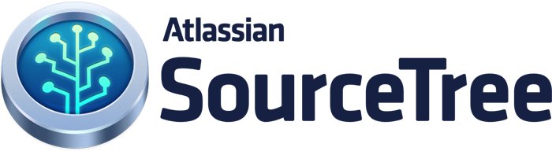In addition I have signed up for [github](https://github.com) and downloaded software called [source tree](http://www.sourcetreeapp.com) which is just one of the GUIs for git.

|  |  |
| --- | --- |
| Technical things I learned this week | |
| Version control | * is a system that records changes to a file or set of files over time so that you can recall specific versions later. For the examples i will use software source code as the files being version controlled, though in reality you can do this with nearly any type of file on a computer. If you are a graphic or web designer and want to keep every version of an image or layout (which you would most certainly want to), * is a very wise thing to use. It allows you to revert files back to a previous state, revert the entire project back to a previous state, compare changes over time, see who last modified something that might be causing a problem, who introduced an issue and when, and more. * Using a VCS also generally means that if you screw things up or lose files, you can easily recover. In addition, you get all this for very little overhead. |
| 170px-Git-logo.svg.pnggit | * is a distributed revision control system with an emphasis on speed, data integrity, and support for distributed, non-linear workflows. * was initially designed and developed by Linus Torvalds for Linux kernel development in 2005, and has since become the most widely adopted version control system for software development. * as with most other distributed revision control systems, and unlike most client–server systems, every Git working directory is a full-fledged repository with complete history and full version-tracking capabilities, independent of network access or a central server. Like the Linux kernel, Git is free software distributed under the terms of the GNU General Public License version 2. |